**Monero Poisoned Output and Zcash Quesnelle Exercise**

In this project, you shall test out your skills to find the real source of funds in several examples on different public blockchains.

**Monero Poisoned Output**

Review the transactions below and indicate which user is most likely to be the same use who withdrew funds (whose outputs are shown in purple) from the exchange. Alice, Bob, and Charlie’s transactions have 3 inputs each.

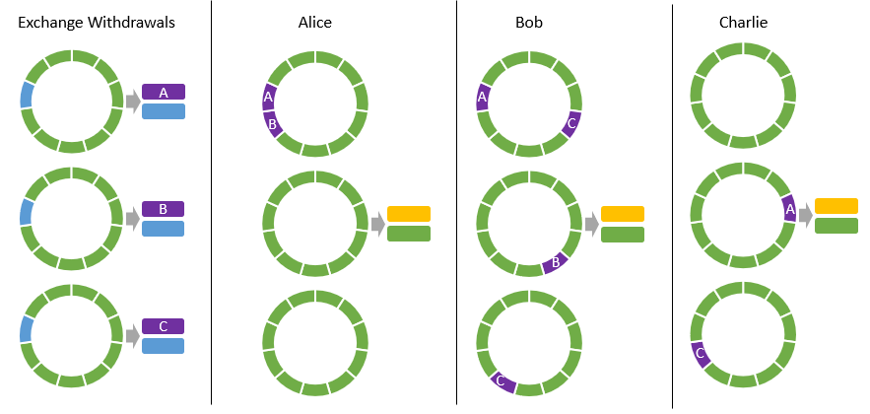

**Zcash Quesnelle**

You observe the following transactions going in and out of the shielded pool. Transactions have a letter that indicates if they are going in or out of the pool, and an identifying number:

**Block 1212**

(i07) 68.5443

(i08) 66776.12

(o09) 2.5672

(o10) 55.33

(o11) 4.32222

(o12) 34.6875

**Block 1211**

(i01) 2.5672

(i02) 67.3882

(o03) 4833.33

(o04) 474.3222

(o05) 5848.44

(o06) 333.333

**Block 1213**

(i13) 2.5672

(i14) 5848.44

(o15) 6689.2

(o16) 466.4443

(o17) 8998.555

(o17) 0.5474733

**Block 1214**

(i1) 8383.112

(i2) 0.473721

(o3) 67.3882

(o4) 68.5443

(o5) 0.47373

(o6) 0.26261

**Block 1215**

(i1) 673.2222

(i2) 222.322

(o3) 0.473721

(o4) 88765.22

(o5) 654.33224

(o6) 0.8765433

Using only the information above, heuristically link the 4 transactions using amounts. Remember that funds need to go into the pool before coming out.